|  |  |
| --- | --- |
|  | **Year 11 ATAR Human Biology**  **Task 8 – DNA and cell reproduction** |

**Assessment type:** Test

**Conditions**

Time for the task: 55 minutes

**Task weighting** – 8%

Total marks 60

|  |  |  |
| --- | --- | --- |
| **Name:** | **Teacher:** | **Date:** |

|  |  |  |
| --- | --- | --- |
|  | **Available Marks** | **Your Score** |
| **Multiple Choice** | **10** |  |
| **Short Answer** | **38** |  |
| **Extended Response** | **12** |  |
| **Total** | **60** |  |
|  | | **%** |

**Section 1: Multiple-choice (10 marks)**

This section has 10 questions. Answer all questions by circling your choice.

1. The diagram below shows a section of DNA undergoing replication.

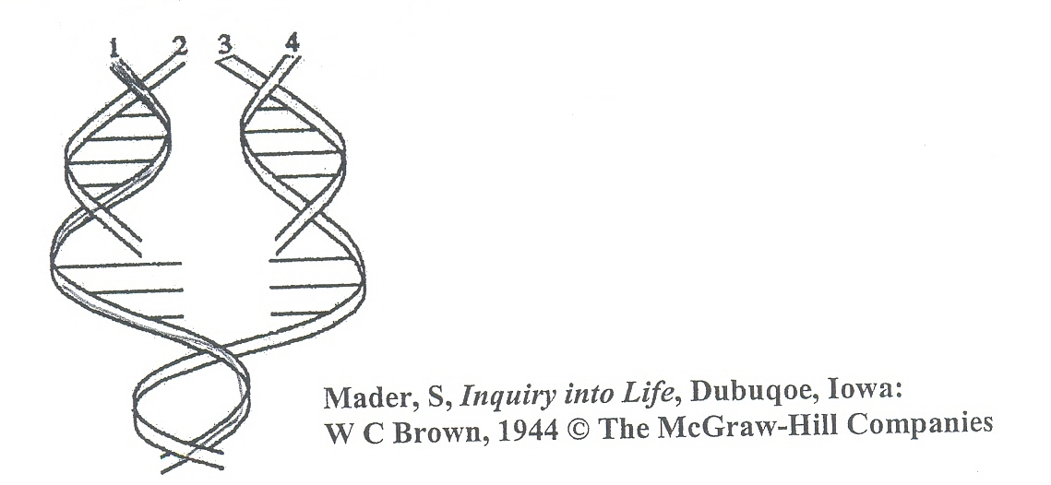

Which two strands of DNA would the sequence of bases be the same?

1. 1 and 4.
2. 2 and 3.
3. 3 and 4.
4. 2 and 4.
5. Which of the following statements regarding DNA replication is true?
6. DNA replication does not require enzyme activity.
7. The ribosomes carry out DNA replication.
8. The process of DNA replication occurs in the nucleus of the cell.
9. DNA replication is the major process by which genes are rearranged along a chromosome.
10. The enzyme responsible for making the double stranded DNA molecules come apart during transcription is:
11. amylase.
12. polymerase.
13. helicase.
14. protease.
15. RNA molecules have the base uracil instead of:
16. guanine.
17. thymine.
18. adenosine
19. none of the above.
20. Altering the expression of a gene without changing the gene structure is called:
21. transcription.
22. translation.
23. gene expression.
24. epigenetics.
25. Examples of environmental agents that may cause epigenetic changes are:
26. severe stress.
27. nutritional factors.
28. drugs.
29. all of the above.
30. DNA codes for the sequence of amino acids in a protein. The diagram below shows a section a DNA strand.

Using the base pair rule, which of the following shows the correct complimentary DNA strand?

1. ATGTCCCCCT
2. UCGTCCCCCU
3. ACGTCCCCCT
4. GCTGCCCCCG
5. If prophase is the beginning what is the end of cell division?
6. Telophase.
7. Metaphase.
8. Interphase.
9. Anaphase.
10. The attachment of acetyl molecules to the histones:
11. makes it harder for gene reading mechanisms to access genes.
12. makes it easier for gene reading mechanisms to access genes.
13. reorganises the sequence of genes.
14. assists methyl molecules to attach to DNA.
15. Embryonic stem cells are cultured from:
16. red blood cells.
17. blood of the placenta.
18. blood of the umbilical cord.
19. inner cell mass of a blastocyst.

**End of Section 1 – Turn over for Section 2**

**Section 2: Short answer (38 marks)**

This section has five questions. Answer all questions. Write your answers in the spaces provided.

______________________________________________________________________________

**Question 11 (5 marks)**

During translation, the codons on the mRNA are read by the ribosomes. The chart below shows the amino acids that are associated with each of the nitrogenous base combinations.

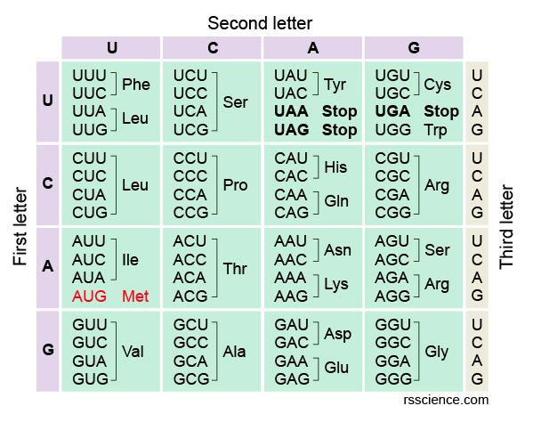To read the chart, the first letter of the codon is located on the left, followed by the second across the top, and then the third on the right hand side. Each amino acid has a three-letter abbreviation to represent it and the order of the codons will describe the sequence of the amino acids in the protein produced.

1. What would the amino acid sequence be if the code exiting the nucleus was:

**5’AUGGAGUUACAC 3’**

________________________________________________________________________

(2 marks)

1. Carrier molecules bring the amino acids to the ribosome to allow protein synthesis to be completed. Answer the following questions about this process.
2. What is the name of the carrier molecule? _________________________________

(1 mark)

1. Halfway along the length of the chain of nucleotides of this carrier molecule is a tight loop. The three bases found here form the: _____________________________

(1 mark)

1. What happens to the carrier molecule after it has delivered the amino acid to the ribosome?

________________________________________________________________________

(1 mark)

**Question 12 (5 marks)**

The diagram below shows the structure of a tRNA molecule.

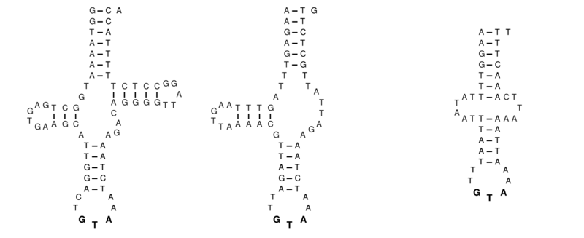

1. Explain the structure of the tRNA molecule that gives it this specific shape.

________________________________________________________________________

________________________________________________________________________

________________________________________________________________________

________________________________________________________________________

(3 marks)

1. Describe one structural difference between mitochondrial DNA and nuclear DNA.

_______________________________________________________________________

________________________________________________________________________

(2 marks)

**Question 13 (5 marks)**

Occasionally cells can become abnormal, invading and damaging the tissues of the body. These diseases can be diagnosed as cancer.

1. Describe how cancer develops and suggest one way it can spread throughout the body (metastasise).

________________________________________________________________________

________________________________________________________________________

________________________________________________________________________

(3 marks)

1. State two ways that you can reduce the risk of getting cancer later in life.

________________________________________________________________________

________________________________________________________________________

(2 marks)

**Question 14 (19 marks)**

Tim, a 3-year-old, was diagnosed with leukaemia. At birth, his parents had organised for his cord blood to be banked. The doctors used the stem cells within the cord blood to treat Tim.

1. Circle the type of stem cell that is found in the cord blood.

Embryonic Adult

(1 mark)

1. Leukaemia is a cancer in which the bone marrow produces abnormal white blood cells that interfere with the body’s normal blood cells. Describe the process by which the cord blood could be used to treat Tim.

________________________________________________________________________

________________________________________________________________________

________________________________________________________________________

________________________________________________________________________

(3 marks)

1. Compare pluripotent and multipotent stem cells.

________________________________________________________________________

________________________________________________________________________

________________________________________________________________________

________________________________________________________________________ (3 marks)

1. Complete the table below, comparing mitosis and meiosis in humans.

|  |  |  |
| --- | --- | --- |
|  | **Mitosis** | **Meiosis** |
| Number of cells produced |  |  |
| Number of chromosomes in daughter cells |  |  |
| Location of occurrence |  |  |

(6 marks)

1. The diagram shows the mass of DNA (m), before, during and after cell division in one

cell. ​

Name the type of cell division taking place in this cell.

DNA replication cell division

1/2m

2m

m

____________________________________________________________________________

(1 mark)

1. The following diagrams represent a selection of the five (5) different stages of mitosis.

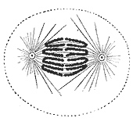 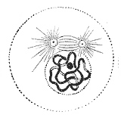 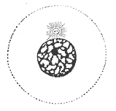

A B C

1. List the diagrams (A, B, C) in the correct order for the process of mitosis.

________________________________________________________________________

(1 mark)

1. Identify the missing stages and draw diagrams to show what would be occurring in each of the missing stages.

(4 marks)

**Question 15 (4 marks)**

Describe two events that can occur during meiosis that will produce gametes with different genetic content.

______________________________________________________________________________

______________________________________________________________________________

______________________________________________________________________________

______________________________________________________________________________

______________________________________________________________________________

______________________________________________________________________________

______________________________________________________________________________

______________________________________________________________________________

(4 marks)

**End of Section 2 – Turn over for Section 3**

**Section 3: Extended answer (12 marks)**

This section has one question. Write your answers in the spaces provided.

______________________________________________________________________________

**Question 16**

DNA is sometimes called the “Code of Life” as it contains all of the information that makes us who we are. One of the most important tasks that DNA performs is the production of proteins.

Briefly describe the structure of DNA, and then explain the process of protein synthesis. Ensure that you are using the correct terminology, and describe where each step takes place. You may include diagrams in your explanation.

_____________________________________________________________________________

_____________________________________________________________________________

_____________________________________________________________________________

_____________________________________________________________________________

_____________________________________________________________________________

_____________________________________________________________________________

_____________________________________________________________________________

_____________________________________________________________________________

_____________________________________________________________________________

_____________________________________________________________________________

_____________________________________________________________________________

_____________________________________________________________________________

_____________________________________________________________________________

_____________________________________________________________________________

_____________________________________________________________________________

_____________________________________________________________________________

_____________________________________________________________________________

_____________________________________________________________________________

_____________________________________________________________________________

_____________________________________________________________________________

_____________________________________________________________________________

_____________________________________________________________________________

_____________________________________________________________________________

_____________________________________________________________________________

_____________________________________________________________________________

_____________________________________________________________________________

_____________________________________________________________________________

_____________________________________________________________________________

_____________________________________________________________________________

_____________________________________________________________________________

_____________________________________________________________________________

_____________________________________________________________________________

_____________________________________________________________________________

_____________________________________________________________________________

_____________________________________________________________________________

_____________________________________________________________________________

_____________________________________________________________________________

_____________________________________________________________________________

_____________________________________________________________________________

_____________________________________________________________________________

_____________________________________________________________________________

_____________________________________________________________________________

_____________________________________________________________________________

_____________________________________________________________________________

_____________________________________________________________________________

_____________________________________________________________________________

(12 marks)

**END OF TEST**